POI 17:

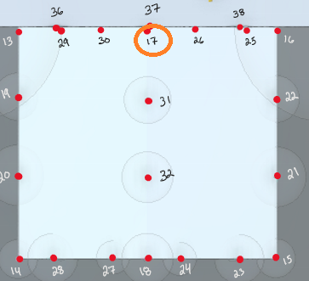

Should pull FQN **@Ron Geyer**

e92b5b9f-5cbd-4622-8e78-31f800a569fb

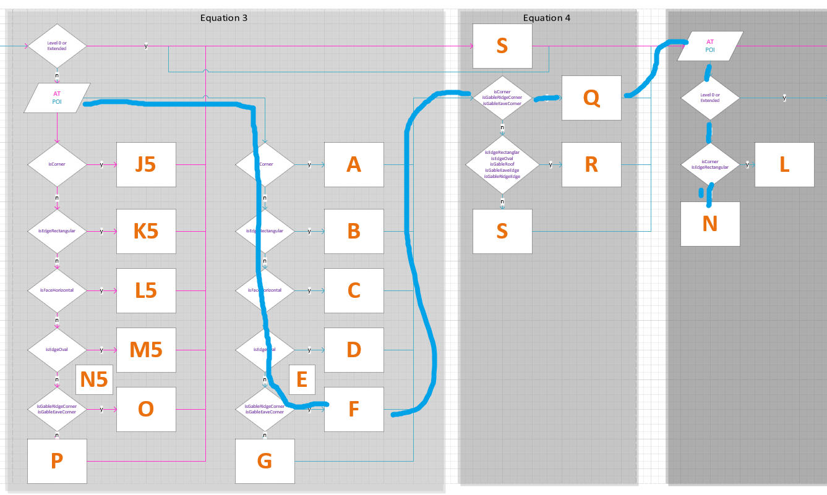

     "isCorner": false,

      "isEdgeRectangular": false,

      "isEdgeOval": false,

      "isCvmEdgePoint": false,

      "isFaceHorizontal": false,

      "isFaceVertical": false,

      "isGableEaveCorner": false,

      "isGableEaveEdge": false,

      "isGableRidgeCorner": true,

      "isGableRidgeEdge": false,

      "isGableRoof": false,

I’m not sure if PoiLocation.Corner pulls the Boolean for isGableRidgeCorner or isGableEaveCorner, should pull equation F

POI 25-26:

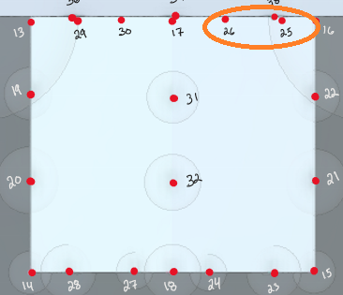

Should pull GRN **@Ron Geyer**

**POI25:** 786d5658-0491-4e6d-af5c-3c9cb2f9281b

**POI26:**

I’m not sure if isGableRoof is considered in the above case statements, should pull equation G

POI 29-30:

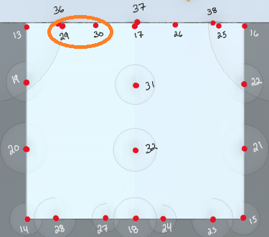

Should pull GRN **@Ron Geyer**

POI29: 8de8acb9-ea3a-4fed-9c52-beb72a0f6bc0

POI30: d221ef73-e106-4e51-a9f4-29a613ecb1e5

POI 36-38:

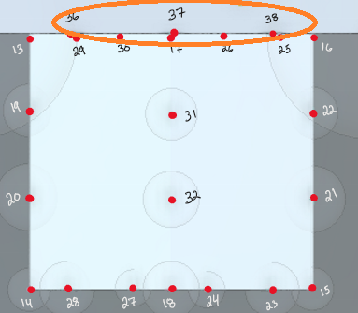

Should pull GRN **@Ron Geyer**

POI 36: 50d7176d-9082-4e8b-8bb2-83b8ad63cf22

**I’m assuming this statement is only for extended and not corner or edge: @Ron Geyer**

**POIs 36, 37, 38 are coming out as if they’re extended and their values match closely with EQ G only**



## Equation 3:

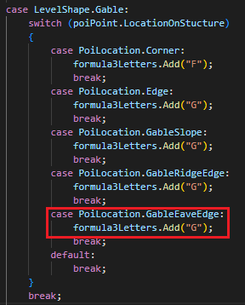

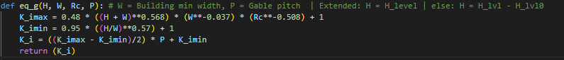

Equation 3 (G) looks good here

## Equation 4:





Equation 4 (R) looks good here

## Equation 5:



Equation 5 (N) looks good here

## Slope:

**Slope seems very different (0.587) whereas spreadsheet calls out 1.65**

Changing slope to 0.587 on spreadsheet pulls a matching(ish) value for POI36

P = 6.1 / 3.7 = 1.648 or close to 1.65 **@ Carlo**

POI 37 has zero slope:

POI 38 has wrong slope:

POI 59- 65:

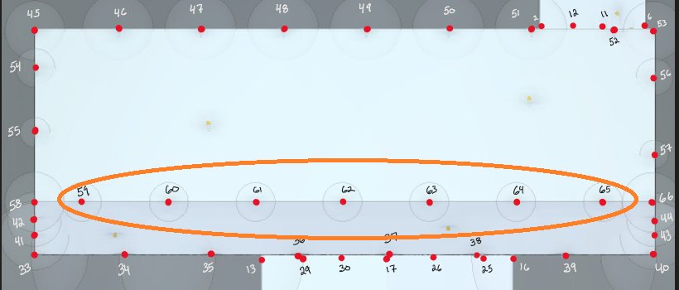

**POI 59:** **0181912c-5e14-4246-91e9-9c3fc0fc0601**

**Slope should be the greater of the two values (1.65) @Carlo**

**POI 60:**

**I’m assuming this occurs for all of the remainder up through POI 65**

POI MAP:

